System Design: Touch Typer

System Overview & Problem Statement

What the System Is
Touch Typer is a containerised web application designed to teach proper touch-typing ergonomics and build typing speed through real-time feedback and intelligent content generation. Unlike traditional typing platforms that present static word lists or randomized key salad, this system acts as a personalized typing coach. It tracks micro-level keystroke telemetry, pinpoints biomechanical weaknesses, and dynamically generates natural, contextual practice sentences tailored to individual muscle memory gaps. Motivation for development is to improve my own touch typing as I am a rookie, but also to create free open source tools to help users to learn how to touch type cause the reality is it is cool asf!!
I am exicted for this one cause its something that I have wanted to develop for a while. The highlights of this project are going to be the containerisation with docker and then the machine learning model that we are going to configure to learn users weak stokes and encourage typing of words with letters of poor score. This way we can cognizantly how well the user can type.

What the System Solves
- The "Plateau" Problem: Most typing tutors treat all errors equally. Users get stuck at arbitrary WPM ceilings because they never isolate the specific finger-transition pair (e.g., f to r or c to e) holding them back.
- Gibberish Fatigue: Primitive adaptive algorithms feed users unpronounceable character strings (e.g., frv frv rvt vtr), breaking natural typing cadence and causing user frustration.
- Poor Finger Mechanics: Beginners often build speed using improper finger assignments, creating bad habits that are difficult to undo later.\\

Core Engine Architecture
The platform relies on two specialized core engines that work synchronously to deliver a complete learning loop.
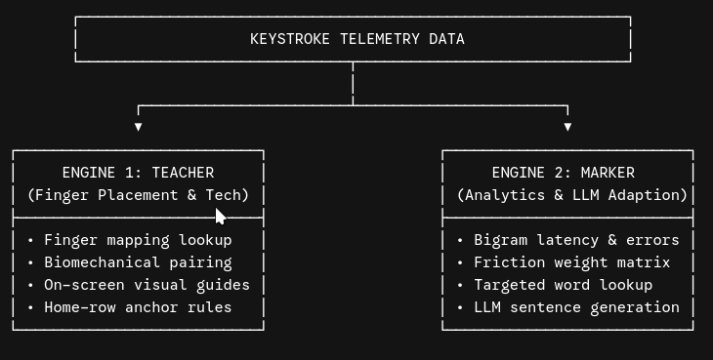

Engine 1: The Teacher (Finger Placement & Mechanical Trainer)
The Teacher Engine enforces proper technique, finger positioning, and spatial layout awareness.
- Biomechanical Finger Mapping: Explicitly maps every key to its designated finger (e.g., Left Index = f, r, v, g, t, b).
- Coordinated Finger Pair Training: Groups keys by finger movement patterns (e.g., index-finger reaches, ring-finger pinky shifts) so the user builds ergonomic coordination before raw speed.
- Guided Visual Keyboard: Feeds real-time layout cues to the frontend to highlight target keys and the corresponding finger to use.

Engine 2: The Marker (Adaptive Analytics & LLM Sentence Generation)
The Marker Engine handles real-time diagnostic evaluation, friction modeling, and content synthesis.
- High-Error Pair (Bigram/Trigram) Tracking: Rather than tracking single-character errors alone, the Marker logs key transitions (k₁ →k₂). It measures the inter-keystroke latency (Δt) and error rates for every key pair (e.g., transition speed from t to h vs. e to r).
- Weighted Friction Matrix: Calculates a difficulty weight for every key pair using speed and error penalties:
Friction Weight(k₁, k₂) = ɑ · Error Count + β ·Transition Latency
where ɑ+β=1
- Two-Step Sentence Generation Pipeline:
  - Pattern Extraction: Identifies the user's highest friction pairs and queries a database dictionary for legitimate English words containing those exact letter combinations (e.g., identifying fr weakness → selecting frame, friction, freeze).
  - Contextual LLM Prompting: Sends the identified target words to a fast LLM API with instructions to construct natural, grammatically correct sentences surrounding those difficult words.
- Scoring & Performance Index: Evaluates completed passages using Net WPM, raw accuracy percentage, and a Rhythm Variance Score (measuring how consistently the user maintains typing tempo).

System Requirements & Technical Specifications

Functional Requirements
Category | Requirement Description
Keystroke Capture | Intercept keydown events with sub-10ms UI render latency; record timestamps, backspaces, and correct key entries.
Adaptive Pipeline | Process user session telemetry immediately upon text completion; update PostgreSQL bigram statistics.
Dynamic Generation | Generate a fresh practice passage within < 1.5 seconds using the LLM API based on current weak points.
Visual Diagnostics | Display a dynamic keyboard heatmap showing key latency (color-coded by speed) and error clusters.
User Persistence | Authenticate users and store historic session logs, WPM progression curves, and personal key friction profiles.

Technical Stack & Infrastructure Constraints
- Frontend: React (TypeScript) + Vite + Tailwind CSS + Zustand (local state management for zero-lag keystroke buffering).
- Backend: FastAPI (Python) + SQLAlchemy (Async ORM) + Pydantic (data validation).
- Database: PostgreSQL (storing users, key metrics, dictionary words, and session history).
- AI/Analytics Layer: NumPy / Pandas (statistical processing) + External LLM API (Groq / OpenAI for passage generation).
- Containerization: Docker & Docker Compose (multi-container setup orchestrating Frontend, FastAPI Backend, and PostgreSQL).

Crucial System Considerations
- Warm-up & Baseline Diagnostic Phase: First-time users need an initial benchmark test (1-2 minutes of standard text) to establish baseline WPM, raw accuracy, and initial finger speed before the adaptive algorithm activates.
- Keyboard Layout Flexibility: While QWERTY is the default, the system architecture should isolate the key-mapping layer so alternative layouts (Dvorak, Colemak) can be supported in future updates without rewriting the telemetry logic.
- Caret & Rendering Performance: Updating React state on every single keystroke can cause visual stutter. Keystroke telemetry must be captured via unmanaged references (useRef) and synced to backend state asynchronously in batches.
- Local Fallback / Offline Mode: If the LLM API is unavailable or rate-limited, the system must gracefully fall back to a local template-based text builder that stitches target dictionary words together without failing the user session.
- Rhythm / Smoothness Metric: WPM and Accuracy don't tell the full story. Tracking keystroke consistency (low standard deviation in typing speed across a sentence) teaches users to avoid burst-and-pause typing habits.

Future Roadmap: Gamification & Modes
To keep users engaged over long periods, the application will introduce gamified challenges:
- Time-Attack Mode: A fast-paced arcade mode where users type as many target words as possible within a 30- or 60-second window. Correct words add bonus time; backspaces cost time.
- Sudden Death / Precision Survival: A mode where a single incorrect keystroke immediately ends the run, forcing users to prioritize 100% accuracy over raw speed.
- Boss Fights / Pattern Rush: A wave-based game mode where incoming targets consist entirely of the user's top 5 historical high-error key pairs. Defeating a wave requires clearing the passage with over 95% accuracy.
- Global & Friend Leaderboards: Track daily, weekly, and all-time high scores for Net WPM and consistency ratings.

